Schools Come Alive
Moving Through the Dimensions
in Physical Education
Participant Handout

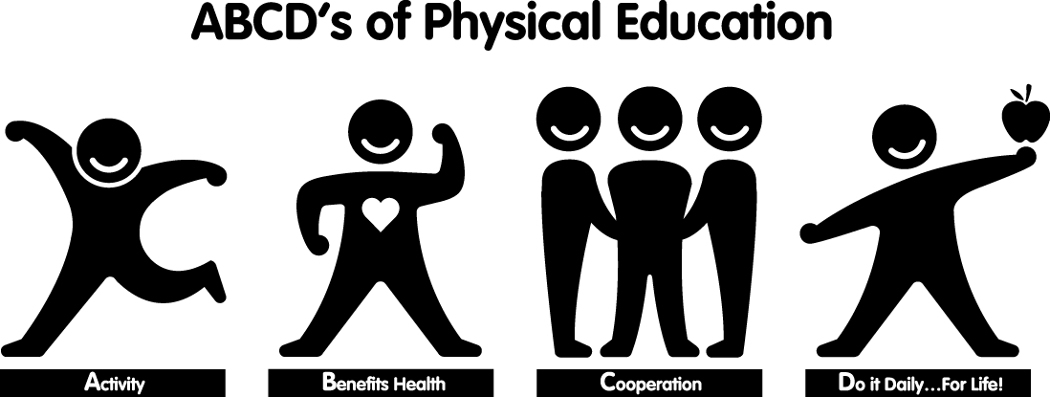

Intended Audience: Grades K-12 Teachers
Workshop Outcomes
Participants will:

- Demonstrate an understanding of Alberta Education’s Physical Education program of studies.
- Participate in a variety of activities to support student learning of Physical Education program outcomes.
- Become familiar with instructional strategies to maximize student participation in physical activity.
- Identify opportunities to access ongoing support and resources.



Shelley Barthel
Project Coordinator
Percy Page Centre - 11759 Groat Road Workshop development supported by:

Edmonton, Alberta T5M 3K6
Ph: (780) 454-4745 Fax: (780) 453-1756
Email: shelley@schoolscomealive.org
Website: www.schoolscomealive.org
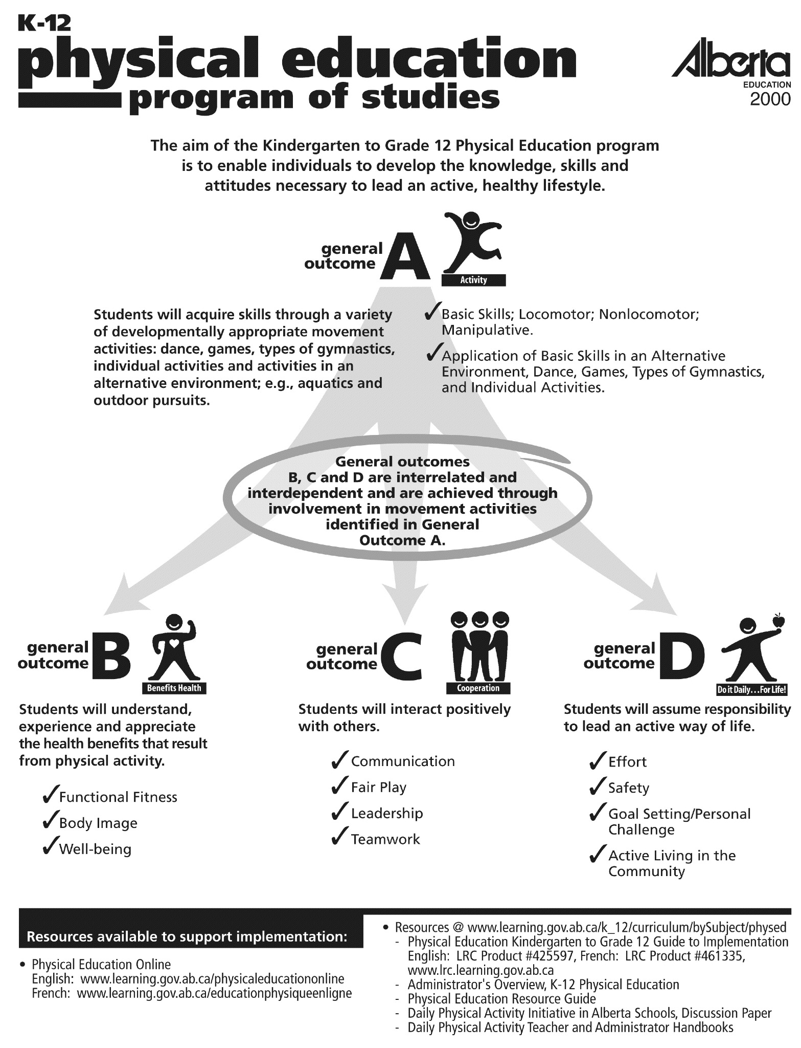

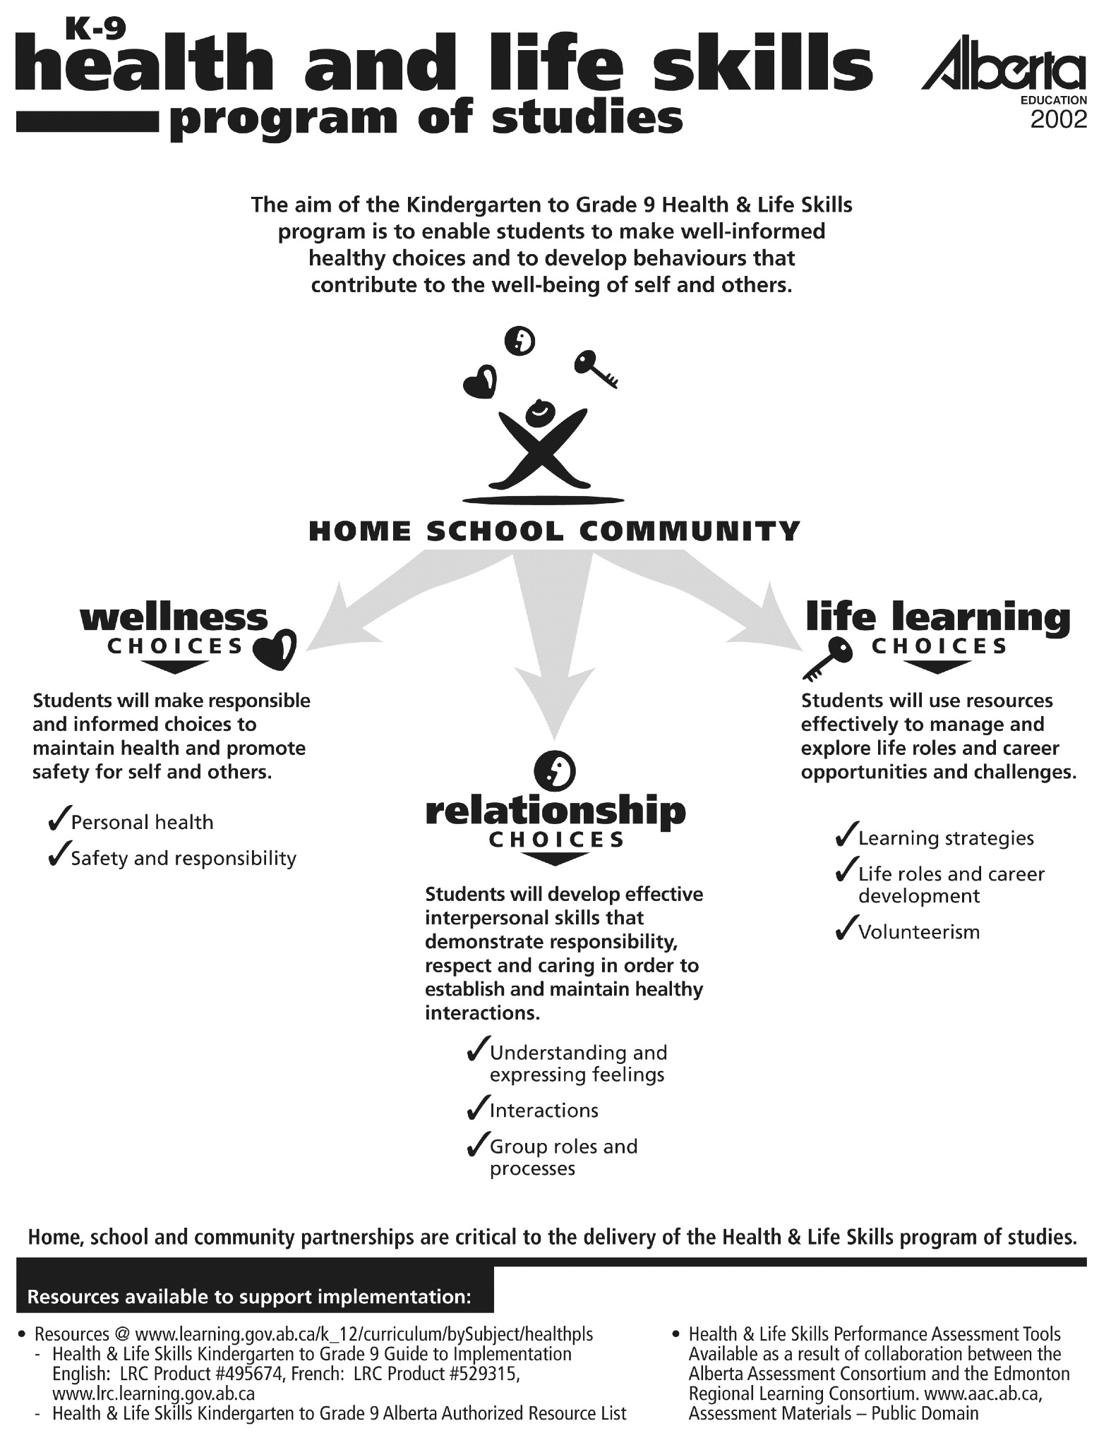

Planning for Physical Education

In our planning as teachers, we know that in order to ensure our teaching is aligned with the program outcomes, best practice is to start with the end in mind (Understanding by Design, Wiggins & McTighe, 1998). The “end”, is student learning and achievement of the program outcomes.

Starting with the end in mind and working backwards in our planning will lead to engaging and effective learning experiences for students. We can start the planning process with the program outcomes, an activity, assessment tools, or an existing unit or lesson. What’s important is not where you start, but that all elements of the final plan support student learning and achievement of the program outcomes.

Important questions to consider when planning for student learning in Physical Education:

- Which outcome(s) will students be working to achieve?





General
Outcomes
 | Activities |  | Benefits Health |  |  | Cooperation |  |  |  | Do It Daily…For Life
 | Basic  Skills | Application of Basic Skills | Functional Fitness | Body Image | Well-Being | Communication | Fair Play | Leader-ship | Team  Work | Effort | Safety | Goal Setting/  Personal Challenge | Active Living In The Community
Specific
Outcomes
- What will I accept as evidence that learning has occurred? What assessment or evaluation tool will I use?

- What activity will facilitate student learning of the knowledge, skills and attitudes of the K-12 Physical Education program? (Remember, no single activity is prescribed)

- How will I organize the activity to ensure learning for all students?

- What are the safety considerations for the activity? (Check the “Safety Guidelines for Physical Activity in Alberta Schools” document as well as your District policies)

Assessment/Evaluation

Sample assessment and evaluation tools for the specific outcomes included in general outcome B – Benefits Health, are included as part of this handout. For more assessment and evaluation ideas, look to the K-12 Physical Education Guide to Implementation, the Teacher Resources section of the Physical Education Online website (www.education.gov.ab.ca/physicaleducationonline) or the Alberta Assessment Consortium (www.aac.ab.ca).

Moving to Inclusion

The outcomes included in the K-12 Physical Education Program are the same for all students, even those with a disability. The “Moving to Inclusion” series of resources is a great source of information and ideas for providing meaningful learning experiences and opportunities for all students in physical education, as well as tips for getting the necessary support to allow all students to learn, have fun, and achieve the program outcomes. A copy of the “Moving to Inclusion” series was sent to all schools in 1994 and is available for purchase or download from the Active Living Alliance for Canadians with a Disability website (www.ala.ca).

Safety and Instruction

The “Safety Guidelines for Physical Activity in Alberta Schools”, suggests minimum guidelines related to equipment, instruction and supervision, to ensure the safest possible physical activity experiences for students. A physically and emotionally safe environment is essential if students are going to learn and have fun!

Consider the following management tips when planning for quality learning experiences with a large number of students:
- Stick to Routines! Establish a signal for stopping and starting activities (e.g., a whistle, drum, hand clap) and practice using it! Consider using both an auditory and visual signal and whenever possible, write directions/expectations on a chalk or whiteboard.

- Get Moving! Students want to and need to move - be sure to maximize activity time for all students during physical education classes. Consider teaching a variety or warm up activities that can be played with two or seventy students. As students enter the gym, post the name of the warm-up activity for the day in a prominent place. Those who are ready for PE will be active right away without needing instruction, allowing you the time to address the needs of those who are ill, injured or late. Ensure that all students have access to equipment and eliminate waiting in lines or sitting out whenever possible.

- Safety First! When many students are moving in an activity space, it is important they can identify safe areas to stop to tie shoelaces, stretch a muscle, catch their breath, etc. Reinforce the importance of stopping on the sideline as opposed to in the middle of the activity space. Encourage students to take care of each other and take responsibility for their actions, which in turn will create a safe activity environment.

- Pack the Sneakers! Staff role modeling participation in physical activity is a powerful motivator for students. Be sure to participate on the perimeter of the activity space, which will allow you to see and supervise all students at all times.

- Have Fun! There are many benefits to participation in physical activity, some of which are reduced stress and anxiety, increased energy levels and improved fitness. Health Canada recommends that adults accumulate 60 minutes of physical activity everyday, so join in and get active!

Alberta Education’s Daily Physical Activity Policy Statement
Starting in September 2005, school boards shall ensure that all students in grades 1-9 are physically active for a minimum of 30 minutes daily through activities that are organized by the school.

Guiding Principles:
- Schools have the responsibility of creating and nurturing a learning environment for students that supports the development of the life-long habit for daily physical activity and for healthy lifestyles.

- Daily physical activities should:
- Vary in form and intensity
- Take into account each student’s ability
- Consider resources available within the school and the larger community
- Allow for student choice
Procedures:
- Boards have the flexibility to use instructional or non-instructional hours to implement Daily Physical Activity.
- Physical education classes are an appropriate strategy to meet the Daily Physical Activity requirement.
- DPA should be offered in as large a block of time as possible but can be offered in time segments adding up to the minimum 30 minutes per day (e.g., two fifteen minute blocks of time for a total of 30 minutes).
- DPA can be incorporated throughout the day and integrated into other subject areas.
- School boards will monitor the implementation of DPA to ensure that all students are active for a minimum of 30 minutes daily.
- Exemptions from DPA may be given by the principal under the following conditions:
  - religious beliefs – upon written statement from the parent to the principal
  - medical reasons – certification to principal by a medical practitioner indicating in which activities the student is not able to participate.

Guide to Education: ECS to Grade 12 September 2005, pp. 32-33
www.education.gov.ab.ca/k_12/curriculum/bySubject/dpa.asp

Activity Ideas

Choose activities that will allow your students to have fun while learning and developing the knowledge, skills and attitudes necessary to achieve the learning outcome(s). A small sample of these kinds of activities is included in this handout. Always be sure to maximize the amount of time students spend being active; the limit is your imagination!
No collection of activities is complete without the sharing of ideas, tips and tricks from many professional peers. Thanks to those teachers who were willing to be creative and share in order to enhance all of our teaching!

ALTERNATIVE ENVIRONMENTS
Students participate in a variety of land-or water-based activities in alternative environments. The selection of activities will depend on the climate, resources and facilities available in the school or community.
General
Outcomes
 | Activities |  | Benefits Health |  |  | Cooperation |  |  |  | Do It Daily…For Life
 | Basic  Skills | Application of Basic Skills | Functional Fitness | Body Image | Well-Being | Communication | Fair Play | Leader-ship | Team  Work | Effort | Safety | Goal Setting/  Personal Challenge | Active Living In The Community
Specific
Outcomes
Specific  Outcomes |  | A(K-30)-11 |  |  |  |  |  |  |  |  | D(K-9)-3
◆ Animal Game
Equipment: Life cards of various animals, “Chance” cards, map of playing area boundaries, skipping ropes.

Organization: Discuss the concept of a food chain. Create life cards for animals on the Animal Game food chain – more life cards for those animals lower on the food chain: e.g.,
Human

Eagle Wolf

Fox Deer

Rabbit Snake

Mouse

A life card can be a piece of laminated construction paper with a picture of the animal, with a hole punched in one corner and an elastic pulled through. Be sure to use different colored paper for each animal. The Animal Game is one giant game of tag, where the goal is to tag as many animals as possible that are lower on the food chain. Each time an animal lower on the food chain is tagged they give one life card to the tagger, i.e., wolf tags rabbit and collects one rabbit life card.

Before beginning play, be sure to outline the boundaries of the playing area. Animals lowest on the food chain receive the most life cards and enter the playing area first – e.g., Mice each receive six life cards and enter the playing area first, rabbits and snakes receive five life cards and enter the playing area one minute after the mice, fix and deer receive four life cards, etc. The human only receives one life card, is the last to enter the playing area, and also receives a sponge ball they can throw to tag animals.

Should any animal lose all of their life cards, they return to “base” (a bench on the tarmac or in the gym) and jump rope for two minutes before choosing and reading a “Chance” card. Chance cards explain a situation that will impact the playing area, students read the card, take the appropriate number of life cards and re-enter the game. Sample Chance cards include:
  - Rabbits have over reproduced and as a result the food supply is low. As a rabbit, you now only have two life cards.
  - A genetically engineered plant has mutated and been eaten by the deer. You are now a deer immune to all viruses.

Variation/Inclusion: Consider adding the elements of virus and natural disaster to the game. While distributing life cards, slip a white “virus” card with one animal. When the animal with the virus is tagged, they receive all but one of the life cards from their tagger, regardless of position on the food chain; i.e., wolf tags deer with the virus card, deer receives all but one life card from the wolf. If the wolf only has one life card left, it is given to the animal with the virus and the wolf heads back to base to skip and choose a Chance card. Ensure all parts of the playing area are accessible for students in a wheelchair, using crutches or other mobility devices. Include pictures on the life cards to indicate where the animal is on the food chain, e.g., which animals are chasing, and which can be chased.

◆ Orienteering Review
Equipment: one clue sheet for every pair of students

Organization: Have students place a hand over their chest or take their pulse to feel their heart rate. Challenge pairs of students to work together to find the correct answers and solve the final equation. Post a number in the location of each correct answer. Consider including an explanation or probing question in the locations of incorrect answers. The challenge is not only to complete the final equation, but also to keep the heart rate elevated throughout the search! Encourage students to check their heart rates often – use heart rate monitors if they are available. When finished, students return to the gym to cool down by drinking water and stretching.

#1 – The other Canadian province to celebrate its centennial year in 2005 is…
Nova Scotia – GO TO the basketball hoops
Saskatchewan – GO TO the entrance to the gym
Manitoba – GO TO the north soccer goal

#2 – The number of icefields in Alberta is…
One – GO TO the portables
Two – GO TO the bench of the east baseball diamond

#3 – Canada’s largest oil strike was in Leduc in 1947, but oil was first discovered in…
Turner Valley – GO TO the bike racks
Fort McMurray – GO TO the playground slide

#4 – Some of the endangered animals that live on Alberta’s prairies are…
Whopping crane, sage grouse, swift fox – GO TO the fire exit door of the gym
Gopher, coyote, magpie – GO TO the south soccer goal

#5 – Alberta’s number one tourist attraction is…
Banff National Park – GO TO the fire hydrant
West Edmonton Mall – GO TO the nearest water fountain
#6 – The first Calgary Stampede was held in…
1912 – GO TO the south soccer goal
1926 – GO TO the picnic tables

#7 – The Blackfoot Chief known as a peacemaker is…
Chief Crowfoot – GO TO the PE equipment room
Chief MacLeod – GO TO the PE office door

_____ + _____ - _____ x _____ + _____ - _____ + _____ = _____
#1 #2 #3 #4 #5 #6 #7 Final Answer!

Inclusion: Ensure clues are located in places that are accessible for all students. Consider allowing students with disabilities to divide the clues between them and work together to solve the final answer.

TYPES OF GYMNASTICS
Students participate in movement challenges that enable them to develop poise, grace, rhythm, coordination, balance, strength, flexibility and effective body mechanics.
General
Outcomes
 | Activities |  | Benefits Health |  |  | Cooperation |  |  |  | Do It Daily…For Life
 | Basic  Skills | Application of Basic Skills | Functional Fitness | Body Image | Well-Being | Communication | Fair Play | Leader-ship | Team  Work | Effort | Safety | Goal Setting/  Personal Challenge | Active Living In The Community
Specific
Outcomes
Specific  Outcomes |  | A(K-9)-12
Funky Furniture
Equipment: Matted area free of obstacles

Organization: Divide students into groups of 6-8. A leader will choose a room or space e.g., kitchen, garage, or bathroom. Students are challenged to create a piece of furniture that might appear in the room chosen by the leader. Each creation must incorporate all group members. E.g., students might create a blender in the kitchen, or a lawn mower in a garage, a washing machine in the basement, etc.

Variation/Inclusion: Limit the number of body parts that can be in contact with the floor to increase the challenge, or allow for the inclusion of various small pieces of equipment. Have students create a sequence creating furniture as they travel through three rooms in a house. Use peer tutors to ensure everyone is involved and has the opportunity to participate. Provide pictures of pieces of furniture to stimulate ideas and creativity. Allow students who are easily distracted to work in smaller groups or with a partner.

Rhythmic Gymnastics
Equipment: Hoops, ribbons, balls, ropes!

Organization: Allow students to choose a piece of equipment and explore moving throughout the space – they will often discover skills and techniques on their own! Allow many opportunities to explore spinning, rotating, rolling, balancing, etc. and challenge students to try a variety of equipment. Further challenge students to create a sequence that starts and ends with a balance (or static position) includes a variety of levels (high, medium, low) and incorporates three elements (such as a bounce, body roll, swing, etc.).

Variation: Have students demonstrate their sequences to small groups of students or to the entire class. Challenge students to use both sides of the body, both hands, and incorporate music if possible!

INDIVIDUAL ACTIVITIES
Students participate in running, jumping and throwing activities; individual manipulatives; combative or self-defense activities, and target activities.
General
Outcomes
 | Activities |  | Benefits Health |  |  | Cooperation |  |  |  | Do It Daily…For Life
 | Basic  Skills | Application of Basic Skills | Functional Fitness | Body Image | Well-Being | Communication | Fair Play | Leader-ship | Team  Work | Effort | Safety | Goal Setting/  Personal Challenge | Active Living In The Community
Specific
Outcomes
Specific  Outcomes | A(K-30)-5 |  | B(K-30)-3 |  |  |  |  |  |  |  |  | D(4-9)-7
◆ Fitness Spelling (Adapted from Everybody Move! Daily Vigorous Physical Activity, CIRA Ontario)
Equipment: A posted list of activities for each letter of the alphabet

Organization: Post an activity for each letter of the alphabet – a sample list is included below. Ensure that all students are able to perform each activity. Challenge students to spell the entire alphabet by completing all activities, or have partners practice spelling words while the other partner guesses each word, or have a leader assign each pair of students a word that they will then complete the activity for each letter in the word.

A – Alternate knee lifts 20x  B – Bicycle pumps 20x  C – Calf raises 20x  D – Dips 10x  E – Energizer bunny hops 20x  F – Free dance your favorite moves 30 seconds  G – Gluteal kicks 10x each leg  H – Hand jive  I – Intense marching on the spot  J – Jumping Jacks 20x  K – Kick your heels together 10x  L – Lunges on each leg 10x  M – Mountain climbers 15x | N – Note your heart rate  O – hOp on each foot 10x  P – push ups 5x  Q – sQuats 10x slow and controlled  R – Run on the spot 15 seconds  S – Skip on the spot with high knees 20x  T – Tae Bo kicks front and back 10x each leg  U – YOU stretch it – reach high and low  V – V-sit 20 seconds  W – Walk around the room once  X – Cross-over steps 10x each direction  Y – Yodel for 10 seconds with your best voice  Z – Zig zag jumps from side to side 20x

Variation/Inclusion: Post letters and activities throughout the activity space encouraging students to move to each letter before completing the action. Have students create new activities or themed activities for each letter of the alphabet. Provide variations to ensure that all students are able to complete each movement – a students in a wheelchair could do tricep extensions over their head instead of dips. Students with visual impairments could work with a partner.

Juggling
Equipment: Juggling scarves, beanbags, or plastic garbage bags for every student

Organization: Distribute the “Juggling” handout from the Teacher Resources – Teaching Tools – PDF Resources section of the Physical Education Online website and have students explore juggling with one, two or three objects. Challenge them to create new juggling patterns (e.g., the elevator: where two objects are thrown up at the same time, and while they lower to the ground, the third object is thrown up between them. Two objects move up and down on the outsides, while the third object moves up and down in the middle – opposite to the others.

Variation/Inclusion: Further challenge students by having them juggle beanbags, rubber chickens and relay batons! Juggle balls by bouncing them off the wall, juggle one scarf, one ball and one rubber chicken, or juggle with a partner! Link to body awareness skills by throwing one scarf up and catching it on a foot, left elbow, head, right knee, etc. Try throwing up one object and clap hands once, clap hands twice, clap hands behind back then front, slap thighs, touch knees, touch toes, turn 360 degrees, throw while standing, sit to catch, throw while standing, lie down to catch! Try partner juggling: toss a beanbag to a partner using two hands, then one hand. When ready, add another object.

GAMES

Students participate in a variety of games to develop individual and manipulative skills, techniques, strategies and spatial awareness. Inherent in playing all games are cooperation, respect for others, fairplay and etiquette.
General
Outcomes
 | Activities |  | Benefits Health |  |  | Cooperation |  |  |  | Do It Daily…For Life
 | Basic  Skills | Application of Basic Skills | Functional Fitness | Body Image | Well-Being | Communication | Fair Play | Leader-ship | Team  Work | Effort | Safety | Goal Setting/  Personal Challenge | Active Living In The Community
Specific
Outcomes
Specific  Outcomes |  |  |  |  |  |  | C(K-30)-3 |  | C(K-30)-5
◆ Squirrel’s Tail
Equipment: 1000+ Popsicle sticks, pylons, 50+ tails of five different colours (material or flags)

Organization: Create five equal teams and assign each team a house. Each house is a corner of the gym, one team along the side of a wall; the boundaries are identified by cones (create a small area). Each team has a different colour tail and each member tucks their tail into the back or side of their shorts – be sure NOT to place the tail through belt loops.

On the signal to begin, teams of "squirrels" attempt to collect "nuts" for the winter. Collect as many nuts as possible by getting to the centre circle without having your tail stolen, collecting one popsicle stick/”nut”, and returning the stick to your house. Then do it all over again! Teams that take more than one stick at a time are made to return all the sticks from their house back to the centre circle.

Squirrels are also able to collect "nuts" by stealing other tails. Squirrels are able to steal another squirrel's tail while they are not in a safe area. Squirrels are safe in their house, and safe when they have one foot in the centre circle where the Popsicle sticks are. In all other places in the gym, any other squirrel can steal their tail. Should a squirrel have their tail stolen, they are no longer able to collect sticks from the centre circle, nor are they able to steal other tails, until they take three popsicle sticks from their own house and "buy" back their tail from the house that stole it for 3 sticks.

Inclusion: Consider designating safe zones where students with mobility impairments can rest for 5-10 seconds before re-joining the game. Place the Popsicle sticks on a desk or chair so they are accessible for students in wheelchairs.

◆ Dice Tag – Dice Tag Canadiana
Equipment: 6-10 foam dice, pinnies

Organization: Have 2-3 students wear pinnies and choose a foam die. These students are “it” and try to tag all other students by touching them with the foam die. All other students start with the number 10. Once tagged, they roll the die and watch for it to stop on a number. That number is subtracted from 10, the student calls their new number out loud and keeps on playing (e.g., a 3 was rolled, new number is 7, student says “7” out loud and keeps playing). When tagged again, subtract the dice number from the new number, and continue until the difference is 0, at which point the student gets their own pinnie and die and becomes a tagger!

Variation/Inclusion: Add instead of subtract – have all students start with 0 and become a tagger when their total reaches 20. Multiply instead of add – have all students choose a number between 1-6 at which to start (e.g., 4x2=8; 8x5=40; 40x3=120…) and become a tagger when their total is 200! Consider having students with developmental disabilities focus on identifying the number rolled as opposed to solving the equation. Identify a safe zone where students with mobility impairments can stop for 5-10 seconds before re-joining the game. Try dice tag Canadiana – post a map of Canada covering the names of the provinces and capital cities. Number six of the provinces/territories 1 through 6. Students play the same tag game, but this time when tagged, the tagger chooses “province” or “capital” before rolling the die. The student who are tagged would look at the map and identify the province or capital that corresponds to the number rolled. Consider posting 6 pictures of articles related to different cultures – when students are tagged they need to identify the culture to which the article belongs.

DANCE
Students participate in a wide variety of dance experiences to enhance development of creative, expressive and rhythmical movements. Students gain awareness of and respect for their own and other cultures, enhance cooperation skills and develop skills that are transferable to social situations in the community.
General
Outcomes
 | Activities |  | Benefits Health |  |  | Cooperation |  |  |  | Do It Daily…For Life
 | Basic  Skills | Application of Basic Skills | Functional Fitness | Body Image | Well-Being | Communication | Fair Play | Leader-ship | Team  Work | Effort | Safety | Goal Setting/  Personal Challenge | Active Living In The Community
Specific
Outcomes
Specific  Outcomes |  | A(4-30)-9

◆ Beat Challenge (DPA School Handbook)
Equipment: 1 small object (bean bag, koosh ball, hockey puck) for every 2 students, music with a strong, steady beat.

Organization: This activity challenges students to move to the beat of music while completing various tasks. Pairs of students sit on the floor one meter apart and facing each other. Place a bean bag between each pair – each student will move accordingly to the beat of the music, and try to grab the bean bag before their partner when the music stops. Change partners after each challenge. Students might move to the beat of the music:
  - Tap hands on knees
  - Tap hands on shoulders
  - Clap hands
  - Clap hands, touch knees, touch shoulders (repeat!)
  - Do crunches to the beat of the music
  - Alternate hands in a front support position to the beat of the music
  - Alternate feet in a front support position
Challenge students to create a move with a partner and perform the move to the beat of the music. Continue by challenging pairs to add a second, third and fourth move to the first, performing to the beat of the music. Complete the beat challenge by joining two pairs together to make groups of 4 (or 6). Each group will teach the other their moves and complete the entire sequence to the beat of the music.

◆ Flocking (DPA School Handbook)
Equipment: Themed music with a strong consistent beat, e.g., The Lion Sleeps Tonight (The Tokens), Stayin Alive (Bee Gees), Holiday (Madonna).

Organization: Divide the class into groups of 4 or 5. Each group will find a space and start in a diamond shape (5th person in the middle). All groups members will stand facing the same direction, the person at the front of the group is the first leader. When the music starts, the leader will choose a way of moving and the rest of the group will follow. After 8 or more repetitions of the movement, the leader will jump and rotate to face a new direction – this identifies a new leader who will choose a new movement and continue. The beauty of flocking is that one group may transition and pass through another group while following their leader. Challenge students to incorporate movements at high, medium and low levels.

Variation: Challenge groups to repeat the movements of previous leaders before choosing their own movement. This will challenge groups to create one large sequence with each leader adding a new movement. Try establishing a criteria for the movement of each leader – they must each create a sequence that includes two levels, two pathways and one unique step for a total of 16 beats. Each leader will repeat their sequence twice before choosing a new leader.

◆ Make-a-rena
Equipment: CD player, music

Organization: Lead students through a few line dances, Macarena, Cadillac Ranch, Cotton Eyed Joe (steps to a number of line dances can be found in the Teacher Resources – Teaching Tools – PDF Resources section of the Physical Education Online website, www.education.gov.ab.ca/physicaleducationonline. Then challenge students to make their own dance or practice and teach a line dance to the class.

Variation: Videotape the dances and show to students at a younger age level to promote participation in physical activity. Take pictures of the students dancing and post around the gym or include in a school newsletter.

HEALTHY ACTIVE SCHOOL COMMUNITY!
General
Outcomes
 | Activities |  | Benefits Health |  |  | Cooperation |  |  |  | Do It Daily…For Life
 | Basic  Skills | Application of Basic Skills | Functional Fitness | Body Image | Well-Being | Communication | Fair Play | Leader-ship | Team  Work | Effort | Safety | Goal Setting/  Personal Challenge | Active Living In The Community
Specific
Outcomes
Specific  Outcomes |  |  |  |  |  |  |  | C(K-30)-4 |  |  |  |  | D(K-30)-9
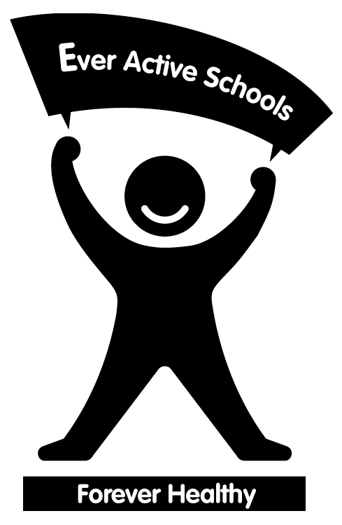
The Ever Active Schools program is a membership-based program available to Alberta school communities. The Ever Active Schools program assists schools in creating a healthy active school community by supporting the achievement of goals identified in each school’s Game Plan. Schools reflect upon the four E’s when building a Game Plan - Education, Everywhere, Everyone, and Environment. The Promising Practices document is a compilation of the best and most unique activities schools in the Ever Active Schools program have hosted, and is one of many resources available on the Ever Active Schools website, www.everactive.org. The following activities are adapted from the Ever Active Schools Promising Practices:

◆ Family Gym Nights
Equipment: School gym, equipment, and members of the school community!

Organization: Family gym nights can be an excellent opportunity to facilitate parents and students being active together. Invite students and their families out to participate in a specific activity that the students have done in P.E. class. For example, set up a “rubber chicken night” where families rotate around a circuit of rubber chicken activities. Have the students teach the activity to the parents, then play together. Involve your parent council to help plan and promote this event.

Inclusion: Try to include activities that use adaptive equipment such as beep and sensory balls. Consider spending an evening introducing families to disability sports like wheelchair basketball, sledge hockey or even different bowling options.

◆ MOGA Madness
Equipment: The imagination of the members of your school community!

Organization: MOGA – Most Outrageous Group Activities are active living challenges created by youth, for youth. The Canadian Intramural Recreation Association (CIRA) compiled a treasury of MOGA activities in 1998. Using these to spark ideas, consider challenging students to plan their own active MOGA event! Sample MOGA activities for large groups include: MOGA Tractor Pull in a farmer’s field with four teams of 100; Giant Centipede Walk; Can-A-Rama where students created a 3.5km “assembly line” and passed cans of food that were donated from a local grocery store to their school field. Each student had a short jog to pass a can to the next student. All 1890 cans were donated to charity.

Inclusion: Involve all students in the creation of the MOGA activity and ensure the activity area is accessible for students of all abilities.

Resources

- Alberta Education
Daily Physical Activity School Handbook, 2005
www.education.gov.ab.ca/k_12/curriculum/bySubject/dpa

- ABCD’s of Movement for Grades 1−6, Edmonton Public Schools, 2002.
LRC $58.00 each grade level, www.lrc.education.gov.ab.ca

- Health & Life Skills Guide to Implementation K-9, Alberta Education, 2002.
English: LRC Product #475964, $26.85
French: LRC Product # 529315, $26.85
Online at www.education.gov.ab.ca/k_12/curriculum/bySubject/healthpls

- MOGA Madness, Canadian Intramural Recreation Association, 1998.
CAHPERD Product AL-TMM-E, $20.00, www.cahperd.ca.

- Moving to Inclusion, National Steering Committee of Moving to Inclusion initiative, 1994.
Product MTI001E, $25.00, Active Living Alliance for Canadians with a Disability, www.ala.ca

- Physical Education Guide to Implementation K-12, Alberta Education, 2000.
English: LRC Product #425597, $20.85
French: LRC Product # 461335, $20.85
Online at www.education.gov.ab.ca/physicaleducationonline

- Physical Education Online
A collection of activities linked to the Alberta Physical Education program outcomes, teaching tips, interactive skill video clips, and much, much more!
www.education.gov.ab.ca/physicaleducationonline - www.education.gov.ab.ca/educationphysiqueenligne

- Ready To Use P.E. Activities for Grades K-2, 3-4, 5-6, 7-9, J. Landy & M. Landy, 1992.
LRC, $44.75 each, www.lrc.education.gov.ab.ca

- Safety Guidelines for Physical Activity in Alberta Schools, Alberta Centre for Injury Control and Research (ACICR) in conjunction with many partnering organizations, 2000.
LRC Product #517063, $18.75, or online at www.med.ualberta.ca/acicr

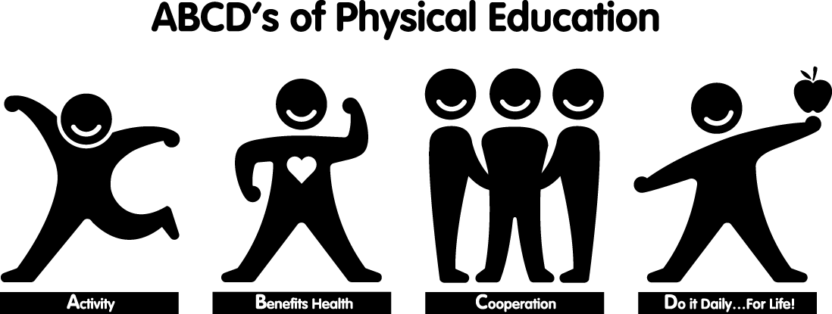
“My muscles are getting bigger and myself of steam has grown!”

Grade Three Student

