Schools Come Alive
Cooperation!
Participant Handout

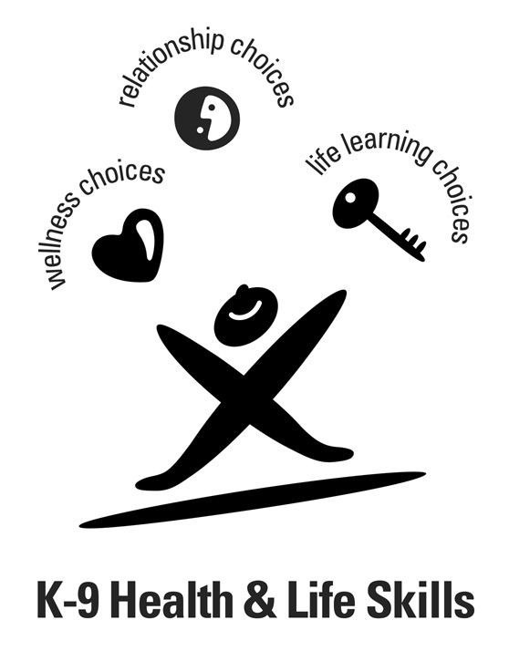

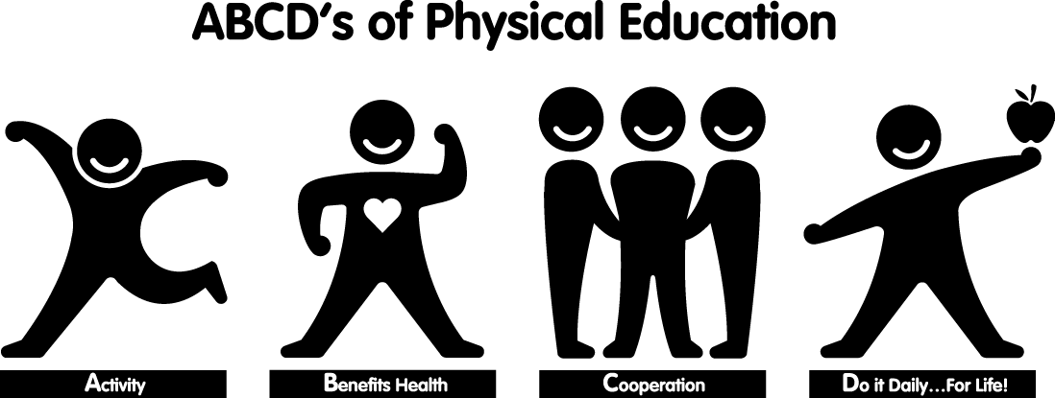

Intended Audience: Grade 1-9 Teachers
Workshop Outcomes
Participants will:

- Participate in a variety of teambuilding activities to support student learning of Cooperation Physical Education and the Relationship Choices Health & Life Skills program outcomes.
- Become familiar with instructional strategies to maximize student participation in physical activity.
- Identify opportunities to access ongoing support and resources.



Shelley Barthel
Project Coordinator
Percy Page Centre - 11759 Groat Road Workshop development supported by:

Edmonton, Alberta T5M 3K6
Ph: (780) 454-4745 Fax: (780) 453-1756
Email: shelley@schoolscomealive.org
Website: www.schoolscomealive.org
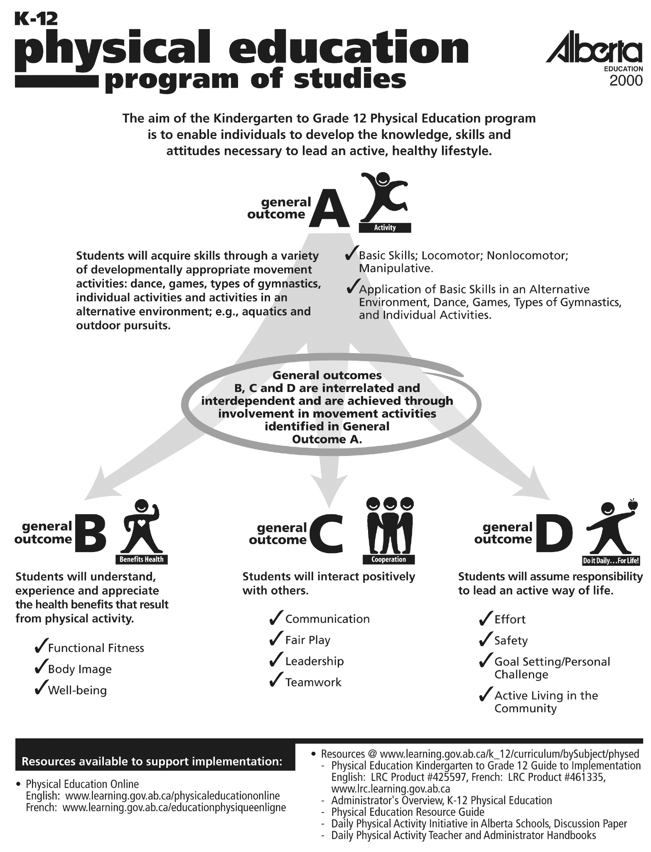

Planning for Physical Education

In our planning as teachers, we know that in order to ensure our teaching is aligned with the program outcomes, best practice is to start with the end in mind (Understanding by Design, Wiggins & McTighe, 1998). The “end”, is student learning and achievement of the program outcomes.

Starting with the end in mind and working backwards in our planning will lead to engaging and effective learning experiences for students. We can start the planning process with the program outcomes, an activity, assessment tools, or an existing unit or lesson. What’s important is not where you start, but that all elements of the final plan support student learning and achievement of the program outcomes.

Important questions to consider when planning for student learning in Physical Education:

- Which outcome(s) will students be working to achieve?

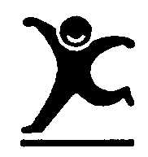

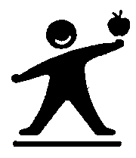
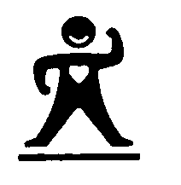
General
Outcomes
 | Activities |  | Benefits Health |  |  | Cooperation |  |  |  | Do It Daily…For Life
 | Basic  Skills | Application of Basic Skills | Functional Fitness | Body Image | Well-Being | Communication | Fair Play | Leader-ship | Team  Work | Effort | Safety | Goal Setting/  Personal Challenge | Active Living In The Community
Specific
Outcomes
- What will I accept as evidence that learning has occurred? What assessment or evaluation tool will I use?

- What activity will facilitate student learning of the knowledge, skills and attitudes included in the K-12 Physical Education program? (Remember, no single activity is prescribed)

- What are the safety considerations for the activity? (Check the “Safety Guidelines for Physical Activity in Alberta Schools” document as well as your District policies)

Assessment/Evaluation

Sample assessment and evaluation tools for the specific outcomes included in general outcome C – Cooperation, are included as part of this handout. For more assessment and evaluation ideas, look to the K-12 Physical Education Guide to Implementation, the Teacher Resources – Teaching Tools section of the Physical Education Online website (www.learning.gov.ab.ca/physicaleducationonline) or the Alberta Assessment Consortium (www.aac.ab.ca).

Moving to Inclusion

The outcomes included in the K-12 Physical Education Program are the same for all students, even those with a disability. The “Moving to Inclusion” series of resources is a great source of information and ideas for providing meaningful learning experiences and opportunities for all students in physical education, as well as tips for getting the necessary support to allow these students to learn, have fun, and achieve the program outcomes. A copy of the “Moving to Inclusion” series was sent to all schools in 1994.

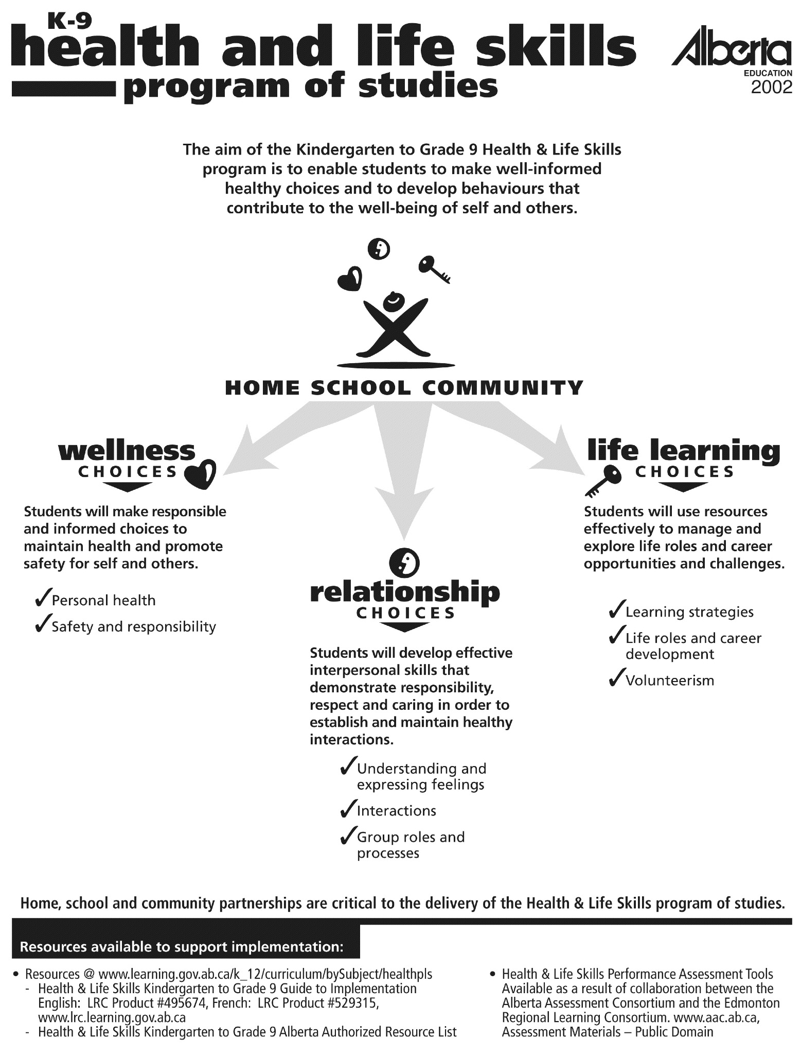

Planning for Physical Education

In our planning as teachers, we know that in order to ensure our teaching is aligned with the program outcomes, best practice is to start with the end in mind (Understanding by Design, Wiggins & McTighe, 1998). The “end”, is student learning and achievement of the program outcomes.

Starting with the end in mind and working backwards in our planning will lead to engaging and effective learning experiences for students. We can start the planning process with the program outcomes, an activity, assessment tools, or an existing unit or lesson. What’s important is not where you start, but that all elements of the final plan support student learning and achievement of the program outcomes.

Important questions to consider when planning for student learning in Physical Education:

- Which outcome(s) will students be working to achieve?

General
Outcomes
 | Activities |  | Benefits Health |  |  | Cooperation |  |  |  | Do It Daily…For Life
 | Basic  Skills | Application of Basic Skills | Functional Fitness | Body Image | Well-Being | Communication | Fair Play | Leader-ship | Team  Work | Effort | Safety | Goal Setting/  Personal Challenge | Active Living In The Community
Specific
Outcomes
- What will I accept as evidence that learning has occurred? What assessment or evaluation tool will I use?

- What activity will facilitate student learning of the knowledge, skills and attitudes of the K-12 Physical Education program? (Remember, no single activity is prescribed)

- How will I organize the activity to ensure learning for all students?

- What are the safety considerations for the activity? (Check the “Safety Guidelines for Physical Activity in Alberta Schools” document as well as your District policies)

Assessment/Evaluation
Sample assessment and evaluation tools for a variety of outcomes that can be achieved through physical activity are included as part of this handout. For more assessment and evaluation ideas, look to the K-12 Physical Education Guide to Implementation, the Teacher Resources section of the Physical Education Online website (www.learning.gov.ab.ca/physicaleducationonline) or the Alberta Assessment Consortium (www.aac.ab.ca).

Moving to Inclusion
The outcomes included in the K-12 Physical Education Program are the same for all students, even those with a disability. The “Moving to Inclusion” series of resources is a great source of information and ideas for providing meaningful learning experiences and opportunities for all students in physical education, as well as tips for getting the necessary support to allow all students to learn, have fun, and achieve the program outcomes. A copy of the “Moving to Inclusion” series was sent to all schools in 1994 and is available for purchase or download from the Active Living Alliance for Canadians with a Disability website (www.ala.ca).

Safety and Instruction
The “Safety Guidelines for Physical Activity in Alberta Schools”, suggests minimum guidelines related to equipment, instruction and supervision, to ensure the safest possible physical activity experiences for students. A physically and emotionally safe environment is essential if students are going to learn and have fun!
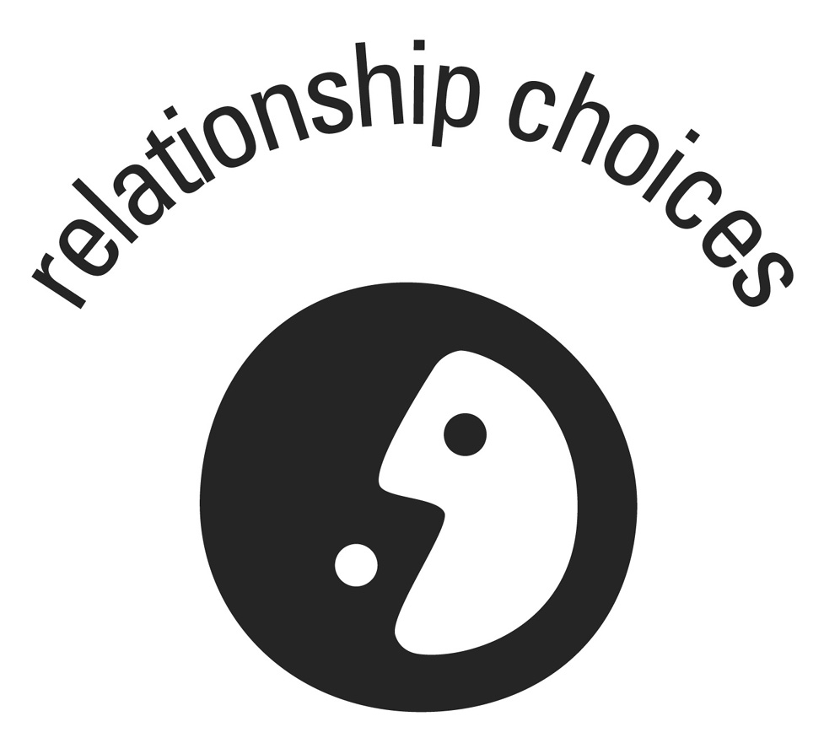  K-12 PHYSICAL EDUCATION  General Outcome C – Cooperation  Students will interact positively with others. | K-9 HEALTH & LIFE SKILLS  General Outcome R – Relationship Choices Students will develop effective interpersonal skills that demonstrate responsibility, respect and caring in order to establish and maintain healthy interactions.
- In order for all students to feel part of the group or team with which they are participating, they must feel they have a voice. Be sure to create situations for all students to have a critical role in the cooperative challenges.
- Discussion is a key component in the process of problem solving and decision-making. Take time to share ideas, observations and conclusions as a large group. Talk about and consider having students record their experiences after participating in cooperative challenges.

Activity Ideas
Choose activities that will allow your students to have fun while learning and developing the knowledge, skills and attitudes necessary to achieve the outcome(s) being assessed. A small sample of these kinds of activities is included in this handout. Always be sure to maximize the amount of time students spend being active; the limit is your imagination!

No collection of activities is complete without the sharing of ideas, tips and tricks from many professional peers. Thanks to those teachers who were willing to be creative and share in order to enhance student learning!

C - COOPERATION IN ALTERNATIVE ENVIRONMENTS
Students participate in a variety of land-or water-based activities in alternative environments. The selection of activities will depend on the climate, resources and facilities available in the school or community.
General
Outcomes
 | Activities |  | Benefits Health |  |  | Cooperation |  |  |  | Do It Daily…For Life
 | Basic  Skills | Application of Basic Skills | Functional Fitness | Body Image | Well-Being | Communication | Fair Play | Leader-ship | Team  Work | Effort | Safety | Goal Setting/  Personal Challenge | Active Living In The Community
Specific
Outcomes
Specific  Outcomes |  |  |  |  |  |  |  |  | *C(K-9)5 |  | D(K-9)-5
Health & Life Skills - Relationship Choices – R(K-9)-1

◆ Number Bridge
Equipment: 30 numbered cards or discs, 4 skipping ropes, stopwatch.

Organization: Outside on a field or a tarmac area, place 30 numbered cards on the ground in random order inside a rectangle approximately 3x5 feet in size. Mark the boundaries around the cards with the ropes by laying them on the ground. This is the “number bridge”. Students are grouped into teams of 5-6. Starting from a line at least 10 meters away, on the signal to begin, one group at a time runs to the number bridge. The challenge is to start from number 1 and count up to 30 as fast as possible. While each number is being called out loud, a team member must touch that numbered card with their hand. No body parts are allowed to touch the ground inside the boundary lines and the number cards cannot be moved. Each team will be timed and have several opportunities to discuss strategy and better their time. The record is 14 seconds (most groups start in the 45-60 second range)!

◆ Stepping Stones
Equipment: Obstacle free area, pieces of paper, bases, or squares marked with tape

Organization: Lay out on the floor a straight line of bases (pieces of paper or squares marked with tape) – use one more base than there are group members (groups of 5-6). Students begin by each standing on one base, then move from base to base until they are in reverse order from the original starting position. Group members will need to help one another move and maintain their balance to be successful. Only one student may touch a base at one time; shoes are considered part of the person; no one may touch the floor with any part of the body; if any rules are broken, the entire group starts over again!

Variation: To increase the level of difficulty, change the position of the empty base. To decrease the level of difficulty, allow any two feet to touch one base – e.g., two students may each have one foot on a base. Consider painting stepping stones squares on a tarmac and challenge students to create their own rules!

◆ Orienteering Challenge
Equipment: Number clues placed in various locations on the school grounds, orienteering card for each pair of students (sample below)

Organization: Partners work together to find the number clues and complete the final equation.

#1 – Which meal of the day is the most important to “break the fast” of sleeping through the night?
Breakfast – GO TO the nearest water fountain
Lunch – GO TO the baseball diamond

#2 – Stretching is …
A stress management technique – GO TO the basketball hoops
Least effective when muscles are warm – GO TO the girls change room

#3 – I’m 16 years old, my cardio workout zone is…
70-85% of my max heart rate, ~155 beats per minute – GO TO the SW soccer goal
50-70% of my max heart rate, ~125 beats per minute – GO TO the playground

#4 – The sun rises in the…
East – GO TO the entrance to the gym
West – GO TO the boys change room

#5 – The Special Olympics Oath is…
“Let me win. But if I cannot, let me be brave in the attempt” – GO TO the NE soccer goal
“Opportunity for all, challenge for all, victory for all!” – GO TO the SW corner of the field

#6 – Health Canada recommends that youth accumulate 90 minutes of physical activity by participating in a variety of endurance, flexibility, and strength activities everyday to experience health benefits. Examples of strength activities are…
Gymnastics, wall climbing, and grocery shopping – GO TO the garbage can on the tarmac
Bowling, running, yoga – GO TO the fire extinguisher

#7 – You and a friend are taking a rest during a full day hike on a very hot day. A good snack to provide energy to finish the hike would be…
Orange punch and a chocolate bar – GO TO the PE office door
Trail mix, a banana, and water – GO TO the NE corner of the field

_____ +_____ +_____ -_____ -_____ +_____ +_____ = _____
#1 #2 #3 #4 #5 #6 #7 (Answer of the day!)

Variation: Complete the orienteering course using compasses, on snowshoes in the winter, or in a nearby park area.

◆ *Camp Relocation
Equipment: hoops, beanbags, benches, mats, ropes, towels, sponge balls.

Organization: In the activity area, set up one “camp” for each team of 4-5 students. A camp might include a hoop on the floor as a fire pit, a few beanbags as plates and utensils, a couple mats as bamboo mats on which to sleep, a bench as the log to sit by the fire, or a rope as a snake on the ground. Each group will also be given a map of the school grounds. The map will indicate the spot where students are to relocate their “camp” and set it up exactly as it was when they entered the activity area.

Variation: To increase the level of difficulty, instead of a map, challenge students to find to new location of their camp by using a compass and following a set of coordinates, or add more equipment to each camp. To decrease the level of difficulty, only include a few pieces of equipment in the camp and have groups set up their camps in a designated area a few feet away.

C – COOPERATION IN TYPES OF GYMNASTICS
Students participate in movement challenges that enable them to develop poise, grace, rhythm, coordination, balance, strength, flexibility and effective body mechanics.
General
Outcomes
 | Activities |  | Benefits Health |  |  | Cooperation |  |  |  | Do It Daily…For Life
 | Basic  Skills | Application of Basic Skills | Functional Fitness | Body Image | Well-Being | Communication | Fair Play | Leader-ship | Team  Work | Effort | Safety | Goal Setting/  Personal Challenge | Active Living In The Community
Specific
Outcomes
 | A(K-9)-1 |  |  |  |  |  |  | C(K-9)-4 |  |  | D(K-9)-3
Health & Life Skills - Relationship Choices – R(K-9)-4

Course Challenge
Equipment: A variety of equipment set up to create an obstacle course with many pathways.

Organization: Show students how to travel safely through the obstacle course (e.g., where they are and are not allowed to travel over top of equipment). Allow time for students to explore various ways of successfully traveling through the course. The challenge is then to travel through linked to a partner or two, or three where there must always be contact with the other partners. Further challenge a group to travel through the course while connected and traveling backwards, or while connected and each carrying a ball or beanbag, etc.

Inclusion: Have students brainstorm a cooperative way to travel through the obstacle course that includes all class members!

◆ Funky Furniture
Equipment: Large area free of obstacles, and matted area if students are allowed to be elevated above the floor.

Organization: Groups of 5-8 students are challenged to re-create an appliance/object that would be found in the rooms of a home incorporating all group members. The leader will call out a room (e.g., kitchen, bathroom, garage, etc.) and groups of students work together to create an object of their choice. Challenge students to re-create objects that are stationary, as well as objects that move (blenders, lawn mowers, dishwashers, etc.)

Variation: Vary the number of students in each group. Have students write the names of rooms from any building on pieces of paper and place them in a hat – the rooms are then chosen randomly from a hat.

C – COOPERATION IN GAMES

Students participate in a variety of games to develop individual and manipulative skills, techniques, strategies and spatial awareness. Inherent in playing all games are cooperation, respect for others, fairplay and etiquette.
General
Outcomes
 | Activities |  | Benefits Health |  |  | Cooperation |  |  |  | Do It Daily…For Life
 | Basic  Skills | Application of Basic Skills | Functional Fitness | Body Image | Well-Being | Communication | Fair Play | Leader-ship | Team  Work | Effort | Safety | Goal Setting/  Personal Challenge | Active Living In The Community
Specific
Outcomes
Specific  Outcomes |  | A(K-9)-11 |  |  |  | C(K-9)-1 |  |  |  |  |  | D(K-9)-7
Health & Life Skills - Relationship Choices – R(K-9)-7

◆ Group Juggle
Equipment: A variety of balls, rubber chickens, discs, scoops, etc.
Organization: Divide class into groups of 10-15 students standing in a circle. Identify a leader within each circle – the leader starts the juggle. Start with one ball. The ball is passed randomly around/across the circle until every student has received it and sent it to someone else. The ball must end up back at the leaser. Each student gets the ball only once and they must remember who they received it from and who they sent it to. Repeat so everyone remembers who they are sending and receiving from. Now tell the students you will be adding a number of objects. Explain that juggling is like the many jobs and responsibilities related to their life. Ask the group to establish some rules for ensure the success of the group, allow three minutes for this task. Students will come up with a variety of rules, such as having to make eye contact, having big balls go high and small balls go low, etc. Once the rules are established, one at a time, being adding more balls (always giving them to the leader), until they are all successfully juggling up to 10 balls!

Variation: Change the challenge for the students – challenge the group to pass one ball from person to person as fast as they can – time them with a stopwatch. Students will soon discover that going around the circle, not across is the fastest. Allow 60 seconds to figure out how to be most efficient and then time the group. Incorporate goal setting and emphasize teamwork to help everyone succeed. Inclusion: Roll ball to students who have difficulty catching, who will then roll to the person they are sending to. All other students throw ball to ensure the rolled ball does not get hit.

◆ Berserk
Equipment: Two balls (or other rolling objects) for every participant

Organization: Students start scattered throughout the activity area. A referee and a timer are needed to start the activity. The timer starts the clock when the referee scatters the same number of balls as participants in the activity area. The challenge is for the group to keep every ball in the activity area moving for as long as possible. Should the referee see a stationary ball, they point at yell “berserk!”. The group is allowed six penalties or “berserks” before the time stops. The timer adds one more ball to the playing area every 20 seconds. Choose a new timer and referee and being again!

Variation: Try berserk with balloons or other light objects that must be kept in the air as opposed to keeping balls moving on the ground. Be sure to check for latex allergies before planning balloon activities.

◆ Riverboat
Equipment: 6 each of accordion mats, pylons, skipping ropes, scooters, and hockey sticks.

Organization: Have each group sit behind their equipment at a designated start line. Identify an end line approximately 12 feet away and describe the area in between as the “river”, which each team is challenged to cross without falling in (touching the floor). On the signal to begin, each group must move all team members and pieces of equipment from the start line to the other side of the river without having any body part touch the floor. Should a team member “fall in” the river, the entire group and all equipment must return to start again. Be sure to review safety with each piece of equipment before starting the challenge – only knees, bum, or belly on the scooter, no unfolding, throwing, or crashing the mat to the floor, no tying the rope around a person, all knots tied will be undone by the group, etc.

◆ Blanket Ball
Equipment: 15 towels/small blankets/large T-shirts, 15 foam balls, basketball hoops or targets

Organization: Students work in pairs to complete the challenge of creatively scoring as many hoops as possible. Each pair is given one foam ball and one towel/blanket/T-shirt. Shooting the ball with the towel, they attempt to put the ball in the basketball hoop or target. Challenge students to find creative ways of scoring – e.g., shooting with their back to the net, holding the towel behind their back, shooting under their legs, score and catch the ball before it hits the ground.

Variation: Challenge pairs to pass an object back and forth to each other as many times as possible. How far apart can you be and still complete a pass? How high can you pass and successfully catch it?

◆ The Tie that Binds
Equipment: 1-meter lengths of rope, or shoelaces!

Organization: Provide every student with one length of rope. Students stand facing a partner – one partner ties each end of one rope loosely around their wrists (like handcuffs). The second rope is tied around the wrists of the other partner, but is looped through the first rope so the pair cannot pull apart. The challenge is to unhook the ropes without cutting, slipping wrist through or untying the knots!

C - COOPERATION IN DANCE
Students participate in a wide variety of dance experiences to enhance development of creative, expressive and rhythmical movements. Students gain awareness of and respect for their own and other cultures, enhance cooperation skills and develop skills that are transferable to social situations in the community.
General
Outcomes
 | Activities |  | Benefits Health |  |  | Cooperation |  |  |  | Do It Daily…For Life
 | Basic  Skills | Application of Basic Skills | Functional Fitness | Body Image | Well-Being | Communication | Fair Play | Leader-ship | Team  Work | Effort | Safety | Goal Setting/  Personal Challenge | Active Living In The Community
Specific
Outcomes
Specific  Outcomes |  | A(K-9)-9 |  |  |  |  |  | C(K-9)-4
Health & Life Skills - Relationship Choices – R(K-9)-9

◆ Thunderstorm
Equipment: None

Organization: Have students sit in a semi-circle with the leader standing at one end. Students copy the action of the leader only when the leader passes in front of them. Start by rubbing hands together and progress to snapping fingers, slapping thighs, clapping hands, stomping feet and then reverse back to rubbing hands. The challenge is to stay quiet and listen to the noise the group is creating – it should sound like a thunderstorm rolling in and fading away.

Inclusion: Have students touch fingertips together if they are not able to snap their fingers, give a stick or broom to those students unable to stomp their feet to hit against the ground.

◆ Chair Aerobics
Equipment: One chair for every student, music

Organization: Work with a partner to create patterns of 16 beats each, include patterns using just arms, just legs, whole body, and traveling away from (8 beats) and towards (8 beats) a chair. Record the sequence on paper using pictures, numbers, symbols and words. Share sequences with other groups and combine sequences to make one twice as long! Change the music and dance the sequences again to faster or slower music.

Variation: Cool down and relax performing desk stretches. Reach hands behind body, join hands together and reach for the back wall; place one heel on the ground and lean upper body forward; repeat on the other leg; hold hands out in front of body and slowly turn neck to look over the left shoulder, then right; etc. Inclusion: Use resistance bands to provide resistance and assist with abstract moves such as twist, stretch, curl, etc.

ACTIVITY THROUGHOUT THE SCHOOL COMMUNITY!
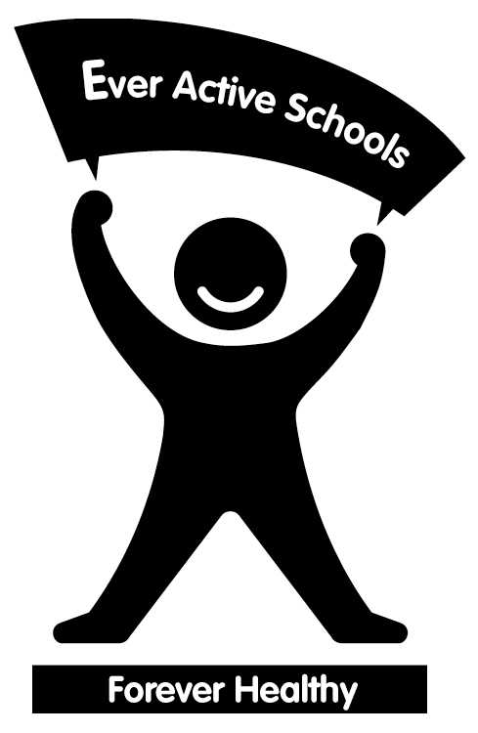
The Ever Active Schools program is a membership-based program available to Alberta school communities. The Ever Active Schools program assists schools in creating a healthy active school community by supporting the achievement of goals identified in each school’s Game Plan. Schools reflect upon the four E’s when building a Game Plan - Education, Everywhere, Everyone, and Environment. The Promising Practices document is a compilation of the best and most unique activities schools in the Ever Active Schools program have hosted, and is one of many resources available on the Ever Active Schools website, www.everactive.org. The following activities are adapted from the Ever Active Schools Promising Practices:

◆ Activity Carts
Equipment: parachute, skipping ropes, juggling scarves, decks of playing cards, sidewalk chalk, Speed Stacks, music CD’s…

Organization: Create an “Activity Cart” for your school. Stock each cart with equipment and ideas for a variety of activities that can be done outside of the gymnasium. Wherever possible, include not only the equipment, but a

Resources

Fair Play for Kids, D. Binder, Fair Play Canada, 1995
LRC Product #39465, $23.35, www.lrc.learning.gov.ab.ca

Health & Life Skills Guide to Implementation K-9, Alberta Learning, 2002
English: LRC Product #475964, $24.30
French: LRC Product # 529315, $24.30
Online at www.learning.gov.ab.ca/k_12/curriculum/bySubject/healthpls

Physical Education Guide to Implementation K-12, Alberta Learning, 2000
English: LRC Product #425597, $14.75
French: LRC Product # 461335, $14.75
Online at www.learning.gov.ab.ca/k_12/curriculum/bySubject/physed

Moving to Inclusion, National Steering Committee of Moving to Inclusion initiative, 1994. CAHPERD, www.cahperd.ca

Physical Education Online
A collection of activities linked to the Alberta Physical Education program outcomes, teaching tips, interactive skill video clips, and much, much more!
www.learning.gov.ab.ca/physicaleducationonline

Ready To Use P.E. Activities for Grades K-2, 3-4, 5-6, 7-9, J. Landy & M. Landy, 1993
LRC, $42.90 each, www.lrc.learning.gov.ab.ca

Safety Guidelines for Physical Activity in Alberta Schools, Alberta Centre for Injury Control and Research (ACICR) in conjunction with many partnering organizations, 2003
LRC Product #517063, $18.75, or online at www.med.ualberta.ca/acicr

Teambuilding Activities for Every Group, Jones, 1999
CAHPERD Product LD-TBA-E, $26.95/$29.95, www.cahperd.ca

